Prénom : ...................................... | Date : ..............……………......................................

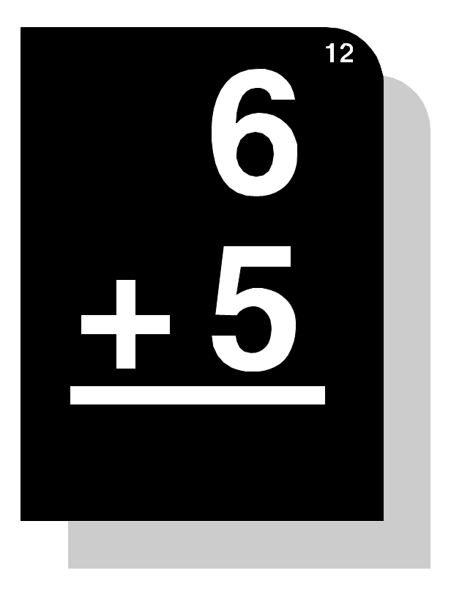(05) | Addition posée en ligne :  48 + 8 = 56 | Addition posée en colonne :  Attention aux retenues !... | ¹48  + 8  56

- Calcule :

¹2 3  + 8  3 1 | 3 3  + 6  3 9 | ¹3 7  + 7  4 4 | ¹2 5  + 9  3 4 | ¹5 9  + 9  6 8 | ¹3 6  + 5  4 1 | ¹7 9  + 1  8 0 | ¹5 8  + 5  6 3
¹ 6  + 3 5  4 1 | ¹ 8  + 5 8  6 6 | ¹ 9  + 2 2  3 1 | ¹ 8  + 7 3  8 1 | ¹ 7  + 1 4  2 1 | ¹ 2  + 4 9  5 1 | 4  + 1 3  1 7 | ¹ 7  + 4 5  5 2
¹ 2  + 1 9  2 1 | 6  + 3 3  3 9 | ¹ 5  + 2 6  3 1 | 6  + 6 0  6 6 | ¹ 3  + 1 8  2 1 | ¹ 2  + 1 9  2 1 | ¹ 9  + 2 2  3 1 | ¹ 8  + 3 8  4 6
¹3 6  + 6  4 2 | 1 7  + 1  1 8 | ¹2 8  + 5  3 3 | ¹1 9  + 9  2 8 | 5 0  + 9  5 9 | ¹1 8  + 3  2 1 | 3 8  + 0  3 8 | ¹4 6  + 5  5 1
1 + 70 = 71 |  | 2 + 39 = 41 |  | 3 + 79 = 81 |  | 4 + 19 = 23
82 + 3 = 85 |  | 63 + 2 = 65 |  | 77 + 6 = 83 |  | 60 + 7 = 67
22 + 9 = 31 |  | 33 + 7 = 40 |  | 27 + 5 = 32 |  | 6 + 70 = 76
88 + 9 = 97 |  | 65 + 4 = 69 |  | 70 + 5 = 75 |  | 45 + 6 = 51
52 + 7 = 59 |  | 25 + 5 = 30 |  | 27 + 3 = 30 |  | 64 + 6 = 70
2 + 39 = 41 |  | 3 + 28 = 31 |  | 7 + 69 = 76 |  | 62 + 8 = 70
8 + 43 = 51 |  | 6 + 24 = 30 |  | 1 + 35 = 36 |  | 6 + 71 = 77
4 + 28 = 32 |  | 8 + 24 = 32 |  | 9 + 61 = 70 |  | 0 + 77 = 77
95 + 0 = 95 |  | 66 + 5 = 71 |  | 48 + 6 = 54 |  | 52 + 5 = 57
55 + 4 = 59 |  | 47 + 3 = 50 |  | 25 + 8 = 33 |  | 65 + 9 = 74
32 + 7 = 39 |  | 80 + 1 = 81 |  | 73 + 7 = 80 |  | 39 + 8 = 47

